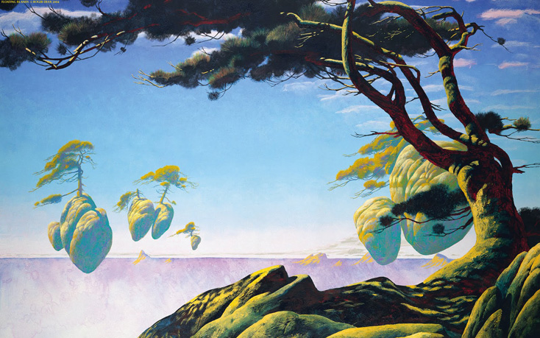

Level Abstract –The Makings of a Scout
  - FTA – Cactus Man Studios
  - Version 0.1
Position Title | Name | Signature
Team Lead / Lead Programmer | Carlos Gutierrez
Lead Artist | Kristy Zeller
Animator | Christina Rhoades
Lead Level Designer | Matthew Langer

Document Designer: | Matthew Langer
Document Date: | 8/8/2014
Intended Product Delivery Date: | 12/18/2014

Document Revisions Table
Version | Description | Date
0.1 | Initial Document | 8/6/2014
1.0 | First Presentable Version | 8/28/2014

Table of Contents
Table of Contents 3
Quick Summary 4
Game Summary 4
Level Summary 4
Hook 4
Gameplay Highlights 4
Setting Summary 5
Mission Difficulty 5
Mission Metrics 5
Characters 5
Visual Themes 7
Key Theme References 7
Reference Art 9
Level Summary 11
Campaign 11
Context 11
Backstory 11
Aftermath 12
Objective(s) 12
Overview Map part 1 13
Level Flow 14
Flow Summary 14
Overview Map part 2 15
Level Flow 16
Flow Summary 16
Overview Map part 3 17
Level Flow 18
Flow Summary 18
MAJOR MILESTONE DAYS PER DISCIPLINE 19
Level Design 19
Art Creation 19
Animation 19
Software Development 19
References 21

Level Abstract

Quick Summary

Game Summary
FTA is a single-player exploration game. To describe the genre of the game, it would best be classified as a, “Mobility Adventure Game”. It is also worth noting that FTA does not contain any combat mechanics and focuses strictly on mobility and exploration.
FTA takes place in a world where a cataclysmic event has shattered the planet into thousands of floating islands. The citizens of this world have made due by colonizing the islands, linking them together, and creating new cities out of the floating landmasses. Magic was once abundant in this world, but after the cataclysm, it has become a rarity.
The player was a soldier in one of the largest capital cities. Part of his equipment is a grappling hook that gives him the ability to swing from island to island with ease. Additionally, he is very strong and agile, allowing him to run along walls and climb high towers. Both these mechanics serve the player with a plethora of mobility solutions in the shattered world.

Level Summary
The first level serves as a tutorial for the player. Here they learn the movement mechanics they will need to master throughout the rest of the game. Within the context of the story, the player character, Arlo, is moving through a series of islands. However, in each new section he remembers training with his brother, Marcus, to become a Leviathan Soldier. The memory of his brother actually appears and moves through the section showing the player how to accomplish their task and provides guidance and encouragement.

Hook
The real appeal of the level and the larger game is the absolute freedom of movement given to the player. With a grappling hook, wall running, double jump, and other level mechanics, the player can move at incredible speeds in all directions. The movement provided is unlike any other game before it.

Gameplay Highlights
This level serves as a tutorial, where the player is introduced to the movement mechanics of the game. It is important to note that this game give the player freedom and agency when choosing how to overcome a challenge. Thus, many highlights would be player created, with only small influences from the designer. However, that being said, there are moments that the design team can count on as becoming large highlights for the player.
- Player’s First Swing: This will be a moment of exhilaration for the player. The mobility and movement provided at this point is freeing and exciting.
- Wall-Run Combo: Within the tutorial is a sequence where the player must bounce back and forth between a set of walls to cross a gap.

Setting Summary
Theme | Freedom
Mood | Light and Fun
Setting | Floating Islands
Time of Day | Evening
Season | Spring. The climate could change per island.
Weather | Cloudy and Misty

Mission Difficulty
Position | Difficulty | Reasons
Beginning | 2 | 2: This is a tutorial, teaching basic movement mechanics
Middle | 3 | 2: This is a tutorial, reinforcing basic movement mechanics
End | 3 | 3: The final part of the tutorial, the player learns the grappling hook and cannon.
Scale: 1-10 (1 is Easiest and 10 is Hardest)

Mission Metrics
Play Time | 5-10 Minutes
Critical Path | Depends on swinging arc At least: 50*350 + 74 * 250 + 38*1000 = 74000 uu
Physical Area | Big?

Characters
Character | Description
Arlo | Age: ~25  DnD Alignment: Neutral Good -> Chaotic Good  Summary: The main character of the story. Escapes from Leviathan in order to obtain “freedom.” His name is Roman (being a citizen of Leviathan) and means “strong, vigorous.”  - Practical to a fault, however his practicality is not natural – was learned from Leviathan  - Rejected the brutal nature of Leviathan, but still has a certain respect for practicality  - Is not a martyr  - Not a coward, but it is important to note he ultimately did run away  - Moral indignation weighs more heavily than the suffering of others  - Uses his morality as a reason to make his life better  - FI in Myers Briggs, but could be a lead FI
Marcus | Age: ~27  Summary: The older brother who the main character left behind in Leviathan. Had just become an Elite soldier before becoming disgraced by Arlo’s desertion. Is now duty bound to hunt Arlo down and return him to Leviathan, with a touch of personal revenge.  In the tutorial Marcus appears as a memory when he taught Arlo how to become part of the Leviathan Guard. Marcus is more cheerful and energetic than his younger brother.
Katherine | Age: looks ~65 actual ~ 300  DnD Alignment: neutral Neutral-> Neutral Evil?  Summary: An old, wizened, and often grumpy woman, she knows much more about the world than either of the other characters. She has a single-minded determination to restore her lost magical powers. She does not trust anybody, and tends to withhold as much information as possible from the other two characters. While old, she is surprisingly skilled in traversal.  - Not so sweet granny type personality  - Former member of Leviathan’s ruling elite until she was exiled after a falling out  - Was once an incredibly powerful magic user, but had her powers sealed when exiled from Leviathan.  - Found Sophie after hearing rumors, decided to use her as an “antenna” to sense magic on her journey  - Uses magic to stay immortal – she is much older than she appears  - Need Sophie to conduct ritual to restore her powers back. This ritual is the same one that caused the apocalypse long ago.  - Tells party that this ritual is to restore the world to what it was before
Sophie | Age: ~11  DnD Alignment: Neutral Good  Summary: A mysterious girl who has the ability to use magic inherently, which is a rare and feared trait. She is inexperienced, but is very curious about the world and will go to great lengths to learn more about it. She is shy and reserved around strangers, but playful with people she knows and finds interesting.  - Curious and inquisitive because she does not know much about the world at all  - Can be naïve but at the same time shows signs of “age” due to traumatic experience  - Is a fast learner, studies skills/magic diligently  - Fears her own magic, due to losing control of it at a young age which caused annihilation of a whole squad of Leviathan solders and caused significant damage to her old town  - She views Katherine as a sort of “teacher/mentor/parent”  - She finds the player character incredibly interesting (came from an evil city, has cool grappling hooks etc.) but does not initially trust him due to his appearance (from Leviathan)

Visual Themes
Theme | Description
Colorful | The world of the game has lots of color. The sky, the grass, the rock of the islands, and other assets use plenty of bright color to satisfy the theme and mood of the game.
Simplified/Minimalist/Stylized | Hand painted textures. This game uses more simple textures with reduced detail. The focus is more on composition of the scene rather than the small detail within it. Additionally, with wall running the player is close to the texture space, and lots of detail could be distracting.
Ruins | Lots of stone, alongside the natural formations. The older architecture from pre-cataclysm is made of stone. However, newer architecture would be more wooden.
Fanciful | A synonym for “Fanciful” according to Webster’s thesaurus is “Castles in the air”; something our game has a lot of. It also provides a perfect description to one of the visual themes.

Concept Art
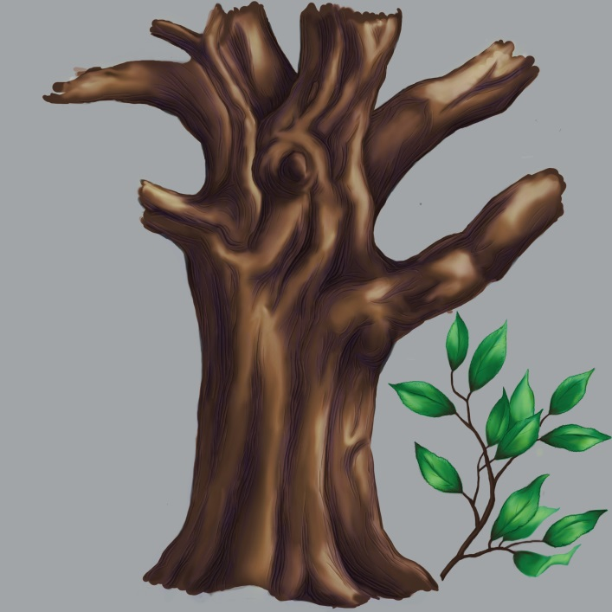
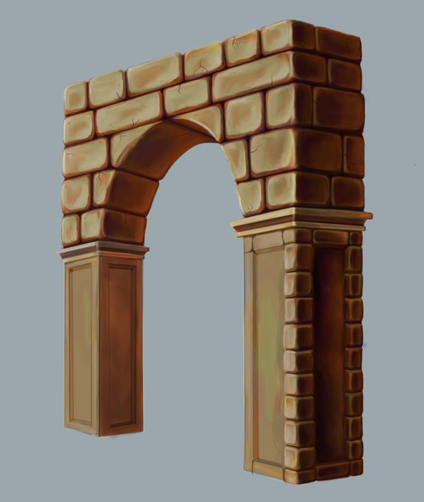

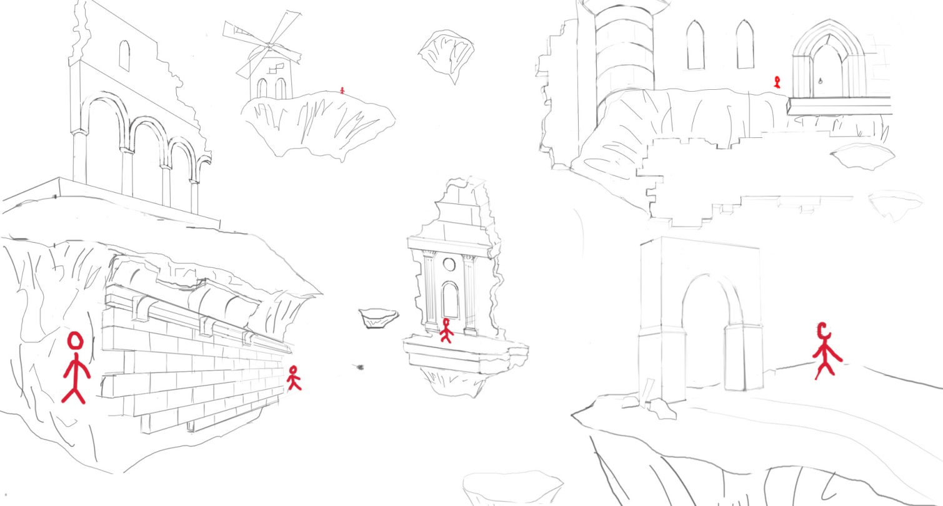

Reference Art

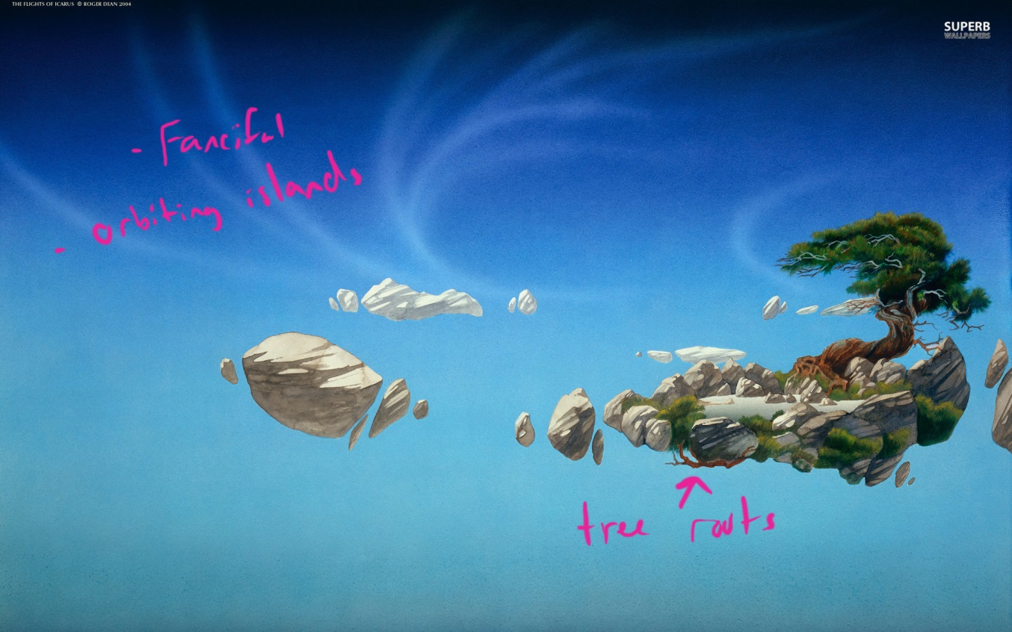
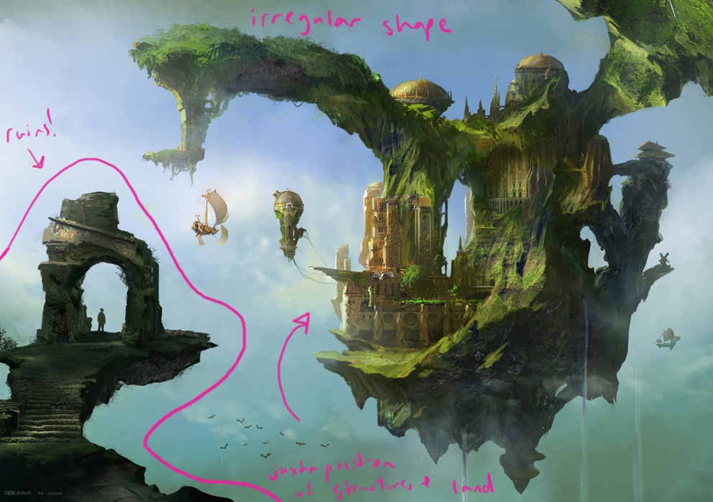
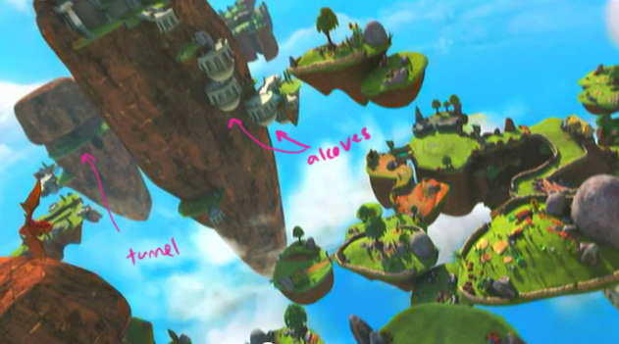
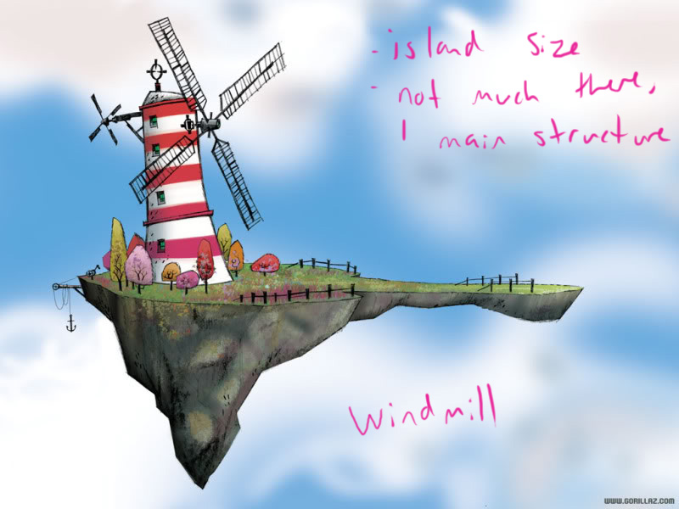

Level Summary

Campaign

Context
The first level serves as a tutorial for the player. Here they learn the movement mechanics they will need to master throughout the rest of the game. Within the context of the story, the player’s character is moving through a series of islands. However, in each new section he remembers training with his brother to become a Leviathan Soldier. The memory of his brother actually appears and moves through the section showing the player how to accomplish their task and provides guidance and encouragement.

Backstory
Long ago, human civilization thrived through powerful combinations of magic and technology. However, one day the Apocalypse rocked the earth and changed it forever. The Apocalypse split the earth and launched fragments of it high into the sky, and hid the rest of the world below in a thick layer of clouds. The fragmented remains of human civilization have been forced to rebuild, having lost most of their technology. In order to survive, nomadic cities were constructed on top of these floating islands, and were made to move using sail or machinery in search of resources. Given the scarcity of resources in this fragmented world, cities would often wage war upon each other, with the winner literally absorbing the loser’s city, and thus their resources, leading to an ecosystem of smaller and bigger cities that would hunt and be hunted. One city known as Leviathan became the most powerful and fearsome due to a combination of ruthless practicality and a huge string of victories in which it consumed countless enemy cities.
In this city’s slums, a boy named Arlo strove above all else to be free. Within Leviathan, the concept of any sort of freedom was completely alien, save for the mysterious few who sat at the very top of society. Over the years, he worked and trained to become a member of Leviathan’s military – a fearsome and universally respected portion of its society. In the military, he learned how to traverse the fragmented world using physical techniques in combination with a specially built grappling hook system. Waiting for an opportune moment, Nero plotted his escape from Leviathan. He knew escaping would make life far worse for the other slum dwellers, but did so anyways when an opportune moment presented itself.
Leaving Leviathan with nothing but his armor, grappling system, and a sort of survivor’s guilt, he set off to explore the remains of the world with his new found freedom. Along the way, he runs into two mysterious Wanderers – Katherine, an old, grumpy, but sage like woman with abundant knowledge of the world, and Sophie, a curious girl who is able to naturally use Magic, an extremely rare and feared trait. Together, they set off to find the secret of the Apocalypse, travelling the world and encountering all manner of people and place along the way.

Aftermath
After the tutorial, the player is woken up by Sophie who tells him that they arrived at the location of the wind essence. This would begin the main part of the campaign where the player must help his two companions to retrieve the white crystals to open up the chamber containing the wind essence.

Objective(s)
- Light the Four Lighthouses
  - Follow the memory of your brother
Overview Map part 1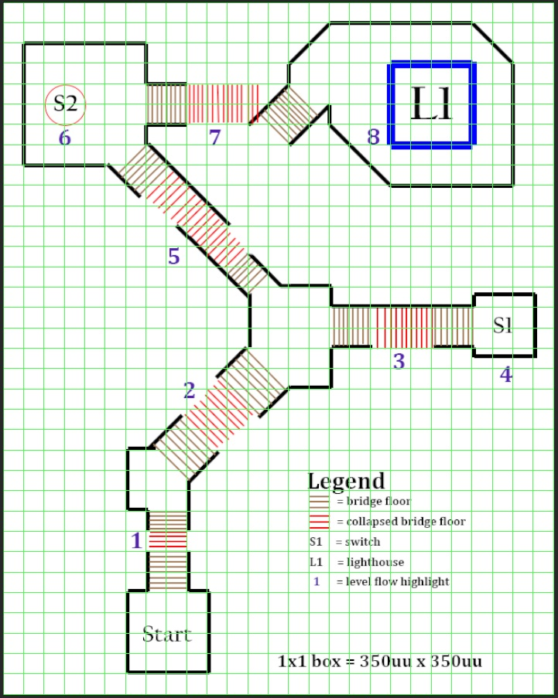

Level Flow

Flow Summary
- The player faces his first challenge: a simple jumping puzzle over a small hole in an interior bridge. As with all challenges in this tutorial level, the player sees a memory of his brother completing them before attempting it.
- The player quickly runs into another bridge but with a larger hole in the floor. The player must use the double jump to get across.
- The player sees yet another gap in a bridge, this one too far for even the double jump. This time the player wall runs along the side of the bridge and jump onto the other side.
- The player activates a switch that lowers the bridges at 5.
- After lowering the bridges with the switch at 4, the player wall runs into one wall, jumps off and wall runs another one before safely reaching the other side of the bridge.
- The player wall runs up a pillar and edge grabs up on top to flip another switch, lowering the bridges at 7.
- After lowering the bridges with the switch at 6, the player double jumps and grabs the limply hanging part of the bridge on the other side and wall runs up it to edge grab and safely land on the island with the first lighthouse.
- The player enters the first lighthouse.

Overview Map part 2
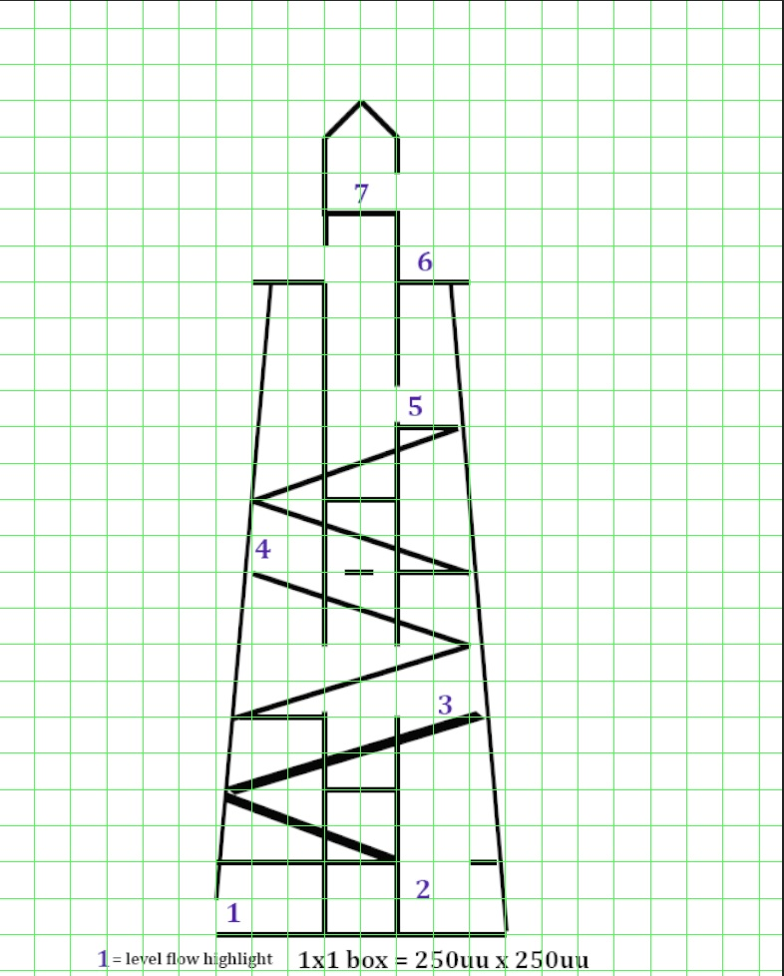

Level Flow

Flow Summary
- The player enters the first lighthouse and sees that there is no staircase waiting for him at the bottom
- The player wall runs up one of the inner sides of the lighthouse to get on the first landing.
- After running up a flight of stairs, the player sees that the next floor’s landing is completely collapsed and decides to double jump through a large hole in the center column of the lighthouse.
- After arriving at the next floor, the player sees a small gap in the column that shows a landing on the other side. This time he wall runs across the inner wall of the lighthouse to land on the other side.
- Arriving at another floor, the player jumps into the central column again and wall jumps up to the exterior of the lighthouse.
- After walking around the exterior, the player finds a crystal and wall runs up the inner column to enter the light chamber.
- The player uses the crystal to light the first lighthouse.

Overview Map part 3
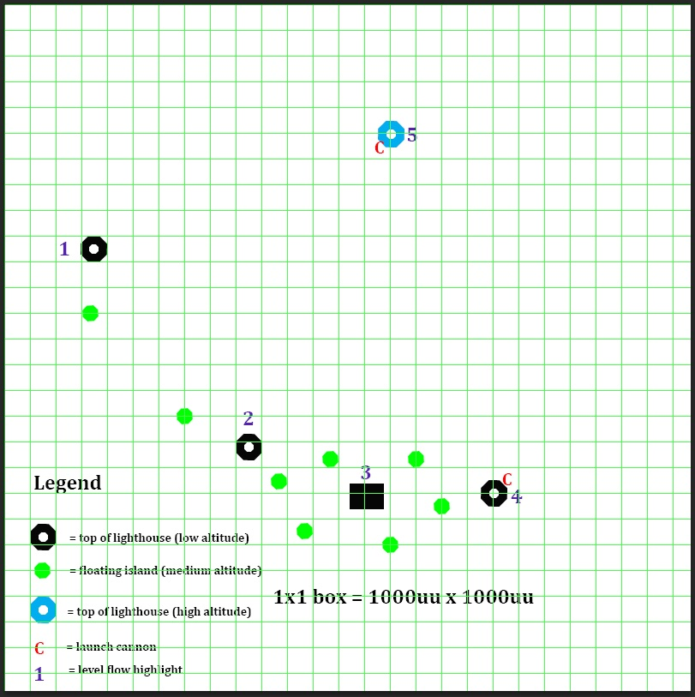

Level Flow

Flow Summary
- The player starts at the top of the first lighthouse after lighting it.
- The player uses his grappling hook to swing to the top of the second lighthouse, picking up a crystal on it and lighting the second lighthouse.
- The player swings through a series of floating platforms to land on a larger one, picking up a crystal and swings to the next lighthouse.
- After arriving at the third lighthouse, the player uses the crystal to light it and enters the cannon and fires at the last lighthouse.
- Landing on the final lighthouse, the player finds the fourth crystal on it and lights it up, triggering a cinematic that ends the dream sequence and starts the main level.

Major Milestone Days Per Discipline
These notes are organized by what content/features will be done by the provided date.

Level Design

August 28th – Level Design Document
September 18th – Whitebox Complete
October 9th – Gameplay Demo

Art Creation

August 29th – Character Concepts Complete
September 12th – Character 1 Model & Texture
September 19th – Character 2 Model & Texture
October 9th – Environment Set

Animation

Note: work that is not directly related to development during this mod is marked with *

August 29th – Facial Rig and Controls*
September 2nd – Facial Rig Animations*
September 16th – All Rigs and Animations
October 9th – Quadruped Rig Due*

Software Development

September 4th – Fundamental Movement
- Jump
- Double Jump
- Horizontal Wall Run
- Vertical Wall Run
- Wall Jump
- Edge grab & climb-up
- Sound Support

September 11th – The Swing Hook
- Swing Hook (Swing)
- Swing Hook (reel-in)
- Swing Hook (Ground correction)
- Swing Hook (Auto Targeting)
- Sound Support
- LD Level Assets I
  - Wind Volume
  - Custom Blueprint Nodes
- Animation Support I (Main Character Testing)

September 26th – Level & Game Integration I
- LD Level Assets II
  - Cannon
  - Door
  - Levers
  - Lighthouse
- Respawning System
- HUD
- Animation Support II

October 9th - Level & Game Integration II
- NPC basic behavior (movement and rotation controls)
- Basic Dialogue system
- Basic Lorebook system

References
Windmill: http://img.photobucket.com/albums/v337/truebeliever01/86428_Windmill20on20island20next20t.jpg

